CL&P AMI AND DYNAMIC PRICING DEPLOYMENT COST BENEFIT ANALYSIS

TABLE OF CONTENTS...……………………………………………………..……………...…………….PAGE
INTRODUCTION 2
DECISION ORDERS 2
EXECUTIVE SUMMARY 2
A. DYNAMIC PRICING PLAN 4
B. COST BENEFIT ANALYSIS 7
C. THE CUSTOMER EXPERIENCE AND IMPACT 10
D. AMI TECHNOLOGY AND STANDARDS DEVELOPMENT 11
E. PLAN TIME LINE 11
F. CONCLUSION 12
G. NEXT STEPS 12

Tables
Table 1 – Pilot Dynamic Pricing Response Adjusted for Typical Summer
Table 2 – Base, Worst and Best Case Scenario Benefits
Table 3 – Base, Worst and Best Case Scenario Costs

Figures
Figure 1 – Dynamic Pricing Cost Effectiveness Chart
Figure 2 - Waterfall Chart of NPV Costs and Benefits
Figure 3 – CL&P AMI & Dynamic Pricing Project Timing

Appendices
Appendix A - Detailed Cost Benefit Analysis and Assumptions
Appendix B - AMI Technology, Standards and Deployments Update
Appendix C - Plan-it Wise Pilot Results - Supplemental Analysis by The Brattle Group

INTRODUCTION
Order No. 4 of the Department of Public Utility Control’s (“Department”) December 19, 2007 decision in Docket No. 05-10-03RE01 (“Decision”) required The Connecticut Light & Power Company (“CL&P” or “Company”) to provide a plan to perform an advanced metering infrastructure (“AMI”) metering study (“Meter Study”), and a plan to conduct a Rate Pilot (“Rate Pilot”), under which it could achieve the Department’s objectives as set forth in Public Act 07-242, An Act Concerning Electricity and Energy Efficiency (“Act”). The Act set out to “support net metering and be capable of tracking hourly consumption to support proactive customer pricing signals through innovative rate design…for all customer classes.”

The Meter Study and the Rate Pilot (collectively, the “Pilot” or “Pilot Program”) objectives were to gather more information about how AMI meters could provide benefits for customers through time-based rates and to provide additional information which would assist the Department in making an informed and fact-based decision about the further deployment of AMI meters.

On December 1, 2009, CL&P reported the Pilot Program results, including customer response to dynamic pricing and a discussion of AMI metering performance. CL&P successfully executed the Pilot with 3,000 customers from June 1, 2009 through August 31, 2009. The Pilot, branded as the Plan-it Wise Energy Program, achieved its objectives to gain insight into customer interest in, and response to, three peak time rates, collectively referred to as “dynamic pricing” rates. At the same time, the Pilot gathered additional experience and insight into the capabilities and maturity of certain AMI technologies. The Company has now used those results to analyze and determine the cost effectiveness of a best, worst and base case set of AMI and dynamic pricing deployment scenarios.

In this filing, the Company is submitting results of the cost benefit analysis, the supporting assumptions for the deployment of AMI and dynamic pricing in CL&P’s service territory, and a recommended AMI and dynamic pricing deployment plan (“the Plan”).

DECISION ORDERS
Order No. 4 of the Decision required CL&P to submit a report regarding the Pilot on or before December 1, 2009. The report was to include, but not be limited to:
- a summary regarding customer response to the Pilot;
- a discussion of the technical capabilities, rural area effectiveness and reliability of the meters; and
- the cost effectiveness of the meters and the rate options.

The Company informed the Department on October 26, 2009 that it would make the required filing on December 1, 2009, but that the initial filing would present only the results of the Pilot. The Company requested, and the Department approved, the filing of additional information required by Order No. 4 by March 31, 2010. This filing presents the cost effectiveness of AMI and dynamic pricing based on a reasonable set of assumptions in a base case scenario, plus worst and best case scenarios.

EXECUTIVE SUMMARY
In response to Order No. 4, the Company submits this compliance filing which presents the costs and benefits of AMI and dynamic pricing, along with a plan for deployment of AMI technology and implementation of associated rate structures. In the Pilot, Peak Time Pricing (“PTP”), Peak Time Rebate (“PTR”), and an eight-hour Time of Use (“TOU”) year-round rate were tested and the results are summarized in Section D – Dynamic Pricing Plan. The Company used the Pilot results along with input and reasonable assumptions about costs and benefits from internal and external sources to develop the Plan.

CL&P hired The Bridge Strategy Group to analyze and quantify cost effectiveness of AMI with dynamic pricing for CL&P under multiple scenarios. In parallel, The Brattle Group analyzed and provided supplemental Pilot results analysis, included in Appendix C. Using data from these processes, the Company developed an AMI and dynamic pricing cost benefit model.

Using the model, the Company analyzed the cost effectiveness of many of AMI and dynamic pricing scenarios. To effectively capture the span of the analysis results, this filing presents a base, plus a worst and best case scenario. A detailed description of cost benefit assumptions for each of those scenarios analyzed is provided in Appendix A - Detailed Cost Benefit Analysis and Assumptions.

Across all scenarios, customers must have a long-term response to dynamic pricing and energy conservation in order to make AMI cost effective at CL&P. The uncertainty in assumptions extending twenty years out has shaped the presentation of the cost benefit analysis herein as a best, worst and reasonable base case scenario.

The Company analyzed surgical AMI deployments (exclusively for customers who sign up for dynamic pricing), geographic deployments (focused on the most cost effective areas), partial deployments (based on customer segment) and a full deployment. Across all scenarios analyzed, a deployment to all CL&P customers (“full deployment”) is the most cost effective scenario that allows dynamic pricing to be offered to all CL&P customers. This is largely due to the operational savings achieved only through a full deployment.

The cost benefit analysis illustrates that while costs are relatively known, the benefits are highly dependent on external variables. The most impactful assumptions are summarized in Section C. The cost of the meter, life of the meter, the value of the forward capacity market, total energy conservation and participation in dynamic pricing programs are the key assumptions most impactful in distinguishing the three full deployment scenarios:
- The best case scenario results in a positive Net Present Value (“NPV”) of $791 million, which is the net of $452 million NPV in costs and $1,243 million NPV in benefits. The major assumptions included in the best case scenario include the following: 1) the average AMI meter cost is $200; 2) the average life of the AMI meter is 25 years; 3) the forward capacity market prices averaged $50/kilowatt-year through 2020; 4); 2% conservation is achieved across all customers; and 5) 80% of residential and 90% of business customers participate in dynamic pricing.
- The worst case scenario results in a negative $392 million NPV, which is the net of $581 million NPV in costs and $189 million NPV in benefits. The major assumptions associated with the worst case scenario include: 1) the average AMI meter cost is $321; 2) the average life of the AMI meter is 15 years; 3) the forward capacity market prices averaged $25/kilowatt-year through 2020; 4) customers show no meaningful level of conservation; and 5) 3.1 percent of residential customers and 4.5 percent of C&I customers sign up for dynamic pricing.
- The base case scenario results in a positive $87 million NPV, which is the net of $493 million NPV in costs and $580 million NPV in benefits. The major assumptions included in the base case are: 1) the average AMI meter cost is $237; 2) the average life of the AMI meter is 20 years; 3) the forward capacity market averaged $38/kilowatt-year through 2020; 4) 1.25% conservation is achieved across all customers; and 5) 25% of residential and 50% of business customers sign up for dynamic pricing programs.

The base case further identifies the following quantifiable benefits, once all meters are deployed and dynamic pricing options are available to all CL&P customers:
- Reduction of peak load by approximately 125 megawatts per year, equivalent of not running a small generation plant;
- Reduction of total energy used by approximately 190 million kilowatt-hours per year, equivalent to the power required for 20,000 homes;
- Reduction of carbon emissions by approximately 100,000 tons per year, which is equivalent to taking over 13,000 cars off the road in Connecticut per year; and
- Reduction of the average storm outage duration by approximately two percent.

The Plan is framed in three phases and includes a four-year AMI meter deployment beginning in late 2012, when required IT capabilities and key external AMI standards and internal IT capabilities will be further developed during Phase 1. These critical timing dependencies are defined here:
- Key standards for AMI, including cyber-security and interoperability which are critical to the successful utilization of AMI. These standards, which, are anticipated to be near completion by mid-2011 will influence decisions around AMI technology selection. Having standards in place will as well as mitigate technical and financial Company risks in selecting and maintaining an AMI solution.
- The Company began developing a Meter Data Management (“MDM”) system in late 2008. The MDM is critical to AMI and dynamic pricing in two ways. First, it will enable the ability to read, store and process hourly energy data. Second, the MDM will be critical in aggregating hourly energy usage into pre-defined peak times to enable dynamic pricing. The MDM platform is scheduled to be implemented in 2011. The Plan extends the platform capabilities to enable critical AMI and dynamic pricing.

During the AMI deployment, the Company will build the additional IT capabilities that are required to provide dynamic pricing, on-bill hourly energy usage analytics, outage detection and other operational benefits. With a four-year AMI deployment, dynamic pricing will be available to all customers by 2016.

The Company requests conditional approval of the Plan to begin an AMI deployment by December 31, 2012, dependent on the Department’s approval of subsequent filings, including cost recovery, no later than July 31, 2012.

DYNAMIC PRICING PLAN

Summary of Pilot Dynamic Pricing Results
The Company successfully achieved the Pilot Program’s objective of gaining an understanding of customer interest in, and response to, time-based rates. Customer participation was statistically significant across each combination of rate, price differential, and enabling technology test. The Pilot provided experience with an AMI solution and four enabling technologies (smart thermostats, smart switches, Energy Orb, Power Cost Monitor).

PTP, PTR and TOU were the three rate designs tested. Each rate design was tested with a high and low price differential of off-peak to on-peak in order to develop a price elasticity curve. The CPP and PTR rates were in effect for a total of 40 hours on 10 days from 2 p.m. to 6 p.m. The CPP program increased prices up to $1.60 per kWh during peak hours, while providing a discount of up to $.05 per kWh during off-peak hours. The PTR program retained normal tariff pricing during all hours of the Pilot, but provided rebates of up to $1.60 per kWh during the peak hours if customers reduced their energy usage during that time. The TOU Pilot rate tested response from noon to 8 p.m. weekdays as the on-peak period, and all other hours as the off-peak period. Under this test the price differential for on-peak versus off-peak was substantially wider than the TOU pricing which exists currently in CL&P’s TOU rates.

The Pilot proved that customer adoption of dynamic pricing will achieve significant peak load reduction. The Pilot dynamic pricing results filed with the Department in Docket No. 05-10-03RE01 on December 1, 2009 have been adjusted using temperature elasticities to estimate what the typical CL&P summer customer response impact would be. The non-weather adjusted summer 2009 Pilot results are presented again in Appendix C. The updated results are presented in Table 1 below. Using Pilot data, Table 1 also presents an extrapolation of the estimated four-hour TOU rate impact would be.

Table 1 – Pilot Dynamic Pricing Response Adjusted for Typical Summer
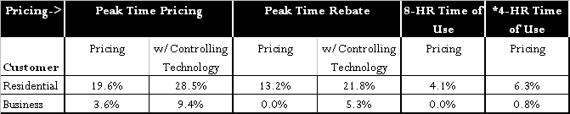

*The eight-hour TOU rate had a low impact and customers in pre-Pilot focus groups and in the post-Pilot customer survey stated the duration was too long for them to be able to significantly respond to. The Brattle Group identified that it is the longest TOU rate they are aware of. Other utility pilots, including the California Statewide Pricing Pilot (“SPP”), have demonstrated that a shorter TOU period would have a higher impact. The impact of the PTP and PTR rates in the SPP pilot are similar to the impact in the CL&P Pilot. Though a four-hour TOU rate was not tested in the Pilot, using the relative impact of CL&P’s Pilot results compared to the SPP results, The Brattle Group was able to provide a reasonable extrapolation of what a four-hour TOU rate impact would be. The analysis process used to determine the impact is described in Appendix C - Plan-it Wise Pilot Results - Supplemental Analysis by The Brattle Group. The results indicate that the impact of a four-hour TOU rate on peak load reduction would be 6.3 percent for residential customers and 0.8 percent for C&I customers.

In support of the dynamic pricing response, controlling technologies like the smart thermostats and smart switches were effective in achieving up to 9 percent additional peak energy usage reduction for Residential customers and nearly 6 percent for C&I customers. However, non-controlling, informational devices like the Energy Orb and the Power Cost Monitor had no statistical peak demand reduction impact.

Cost Effectiveness of Dynamic Pricing, by Rate Type
To determine the cost effectiveness of each dynamic pricing rate, the Company analyzed the cost to market and enroll customers, the value of the dynamic pricing peak load reduction, and the amount of customer participation and persistence of the customer response. For customers actively participating in a dynamic pricing rate, the estimated base case NPV results are represented in Figure 1.

Figure 1 – Dynamic Pricing Cost Effectiveness Chart
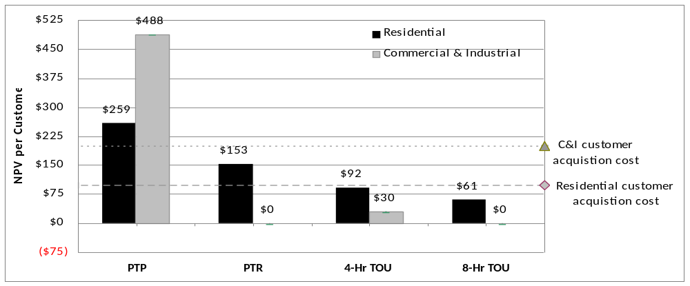

The base case assumes that the acquisition cost per customer, meaning the cost to get a customer to enroll in dynamic pricing, is $100 per Residential and $200 per C&I customer. The benefits of the dynamic pricing response impact must be higher than the costs to customer acquisition cost to be cost effective. The Company finds that:
- PTP is the most cost effective dynamic pricing rate, adding $259 NPV in value per participating Residential CL&P customer and $488 NPV in value per participating C&I customer.
- PTR is also cost effective, adding $153 NPV in value per participating Residential customer; however, PTR is less cost effective than PTP. Given the lack of peak load reduction impact for C&I customers, there is zero value in C&I customer participation in PTR.
- The four-hour TOU rate for Residential and Business customers is also not cost effective unless you couple it with other rates. The $100 Residential customer acquisition costs exceed the $92 value that the four-hour TOU provides from Residential customers, while the $200 Residential customer acquisition costs exceed the $30 NPV value for each participating C&I customer. The four-hour TOU, however, can be cost effective for both Residential and Business customers when coupled with the PTP or PTR, which spreads the customer acquisition costs, making the combination cost effective.
- The eight-hour TOU rate for Residential and Business customers is not cost effective unless you couple it with other rates. The $100 Residential customer acquisition costs exceed the $61 NPV value that the eight-hour TOU provides from Residential customers. However, the eight-hour TOU can be cost effective for Residential customers when coupled with the PTP or PTR by coupling the Residential TOU with the PTR or PTP rate programs. Zero value is added by the eight-hour TOU for C&I customers, given the lack of peak load reduction impact.

Recommended Dynamic Pricing Solution
A full deployment is the only cost-effective deployment scenario that provides the ability to achieve broad participation in dynamic pricing rates for all customers. While every customer will ultimately have a smart meter and have dynamic pricing options, only customers who voluntarily sign up for a dynamic pricing rate will participate.

Using the cost effectiveness results from Figure 1 above and the Pilot results, the Company recommends the following dynamic pricing approach:
- Customer response shows that the PTP rate is the most cost effective and most satisfying to customers. CL&P recommends offering it to all customers to sign up on a voluntary basis.
- The PTR is cost effective, but since it is less cost effective than the PTP, the Company recommends that solely all low income customers should be placed on the PTR rate to encourage participation, while not exposing them to the risk of higher bills that may result as an impact of PTP.
- Given the lower response to the eight-hour TOU relative to a four-hour TOU, the Company recommends no further extension of the rate to residential and C&I customers with peak energy loads less than 100kW.
- Since the four-hour TOU rate is not cost effective by itself for either Residential or C&I customers, CL&P recommends proactively marketing a four-hour TOU rate to all customers only in conjunction with the PTR or PTP rates.
- For all TOU rates offered, the Company recommends using an on and off-peak period price differential similar to the high TOU differential tested in the Pilot, to encourage greater responsiveness.

The Company believes the majority of the dynamic pricing differentials should be reflected in the Generation portion of customer bills. However, CL&P recognizes that additional discussion of the most appropriate unbundled component rate design and recovery is necessary, and recommends that these issues be addressed as the Company moves closer to actual implementation of dynamic pricing as part of the overall time line addressed below.

Controlling Technology Pilot Results & Recommended Approach
Controlling technologies, e.g. smart thermostats, are used to adjust central air conditioning (“CAC”) temperatures during peak time pricing. The Pilot results of the controlling technology impact are presented Table 1 above. In addition to the peak load reduction impact, the Pilot experience also indicated that smart thermostats are still immature from a technology and a customer usability design perspective. Integration of price and controlling signals through the meter, also referred to as Home Area Network (“HAN”) communication, to smart thermostats is also still low on the maturity curve. The effort to set up and provide customer education and customer support for in-home devices was also more significant than expected.

With the Pilot results, the company analyzed the cost effectiveness of deploying controlling technologies to CAC customers and finds that the impact of controlling technologies from participating C&I customers on the PTP add $372 NPV and on the PTR add $261 NPV in value. Residential customers participating with controlling technologies, however, reduce NPV by $46 on PTP and $20 NPV on the PTR.

Based on the cost benefit analysis, while it is not cost effective to provide controlling technologies to Residential customers, there is significant additional value in providing controlling technologies to C&I customers with CAC. However, smart controlling technologies still need to mature from a technical and usability perspective. Until they mature, the Company does not propose building broad deployment assumptions into the scenarios analyzed. The Company will provide an update on the maturity of controlling technologies in the proposed October 31, 2011 informational update filing identified in Section G.

COST BENEFIT ANALYSIS
This section summarizes the cost benefit analysis process and results that were developed using the dynamic pricing plan as described in Section D. Detailed analysis is provided in Appendix A.

The cost/benefit analysis uses the NPV methodology by calculating the costs of deploying and maintaining an AMI infrastructure and comparing those costs against the benefits accrued over the twenty-year meter life. The discount rate used is CL&P’s after-tax weighted average cost of capital (8.23%) proposed in Docket No. 09-12-05. The Company created a base case scenario that incorporates the most probable outcome for the different assumptions included in the analysis. In addition, CL&P developed best and worst case scenarios to provide the Department an assessment of the potential range of outcomes as many of the assumptions are uncertain in nature, especially over a long period of time.

While the costs of the Plan are relatively known, many of the benefits are highly variable and dependent on external factors, such as values of the forward capacity and energy markets, percentage of the total population that is participating in dynamic pricing programs, and the energy conservation achieved by customers.

Figure 2 illustrates the costs and benefits of the base case, worst case and the best-case scenario analyses. Benefits are identified as either system or societal benefits. System benefits are those that accrue to the electrical system through lower operational cost for CL&P or lower system requirements that reduce generation needs, as well as wholesale capacity and energy prices. Societal benefits (e.g., CO₂ reduction) impact the customer either directly or indirectly, but have no direct impact to the electrical system.

The base case scenario analysis is represented by the bars, while the best case is represented by the top green line and the worst case is represented by the bottom red line. The NPV results are $87 million in the base case, $791 million in the best case and $392 million in the worst case.
Figure 2 – Waterfall Chart of NPV Costs and Benefits
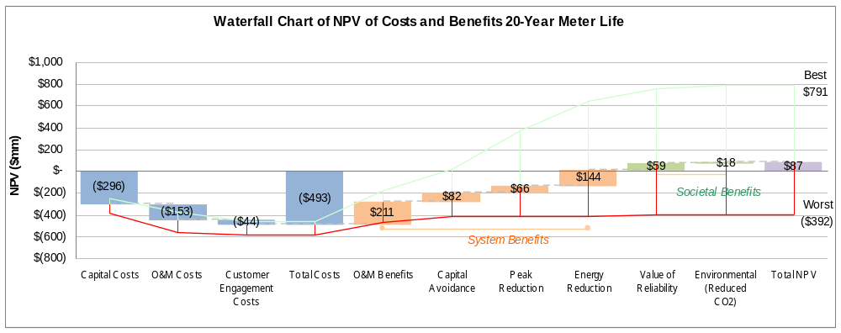

Costs
CL&P evaluated and quantified costs enabled by AMI in three major categories. The summary of costs by scenario is presented in Table 3.

Table 3 – Base, Worst and Best Case Scenario Costs
Cost category | Base case scenario | Best case scenario | Worst case scenario
1) Capital | $296M | $247M | $385M
2) O&M | $153M | $129M | $175M
3) Customer Engagement | $44M | $76M | $21M
Total | $493M | $452M | $581M

The total costs in the base case are $493 million (NPV) and are allocated into capital, O&M and customer engagement costs:
- Capital costs: CL&P identified a total of $296 million in capital costs, which includes $273 million in AMI metering and communication infrastructure costs, $21 million in information technology and $2 million to design initial marketing and education material about dynamic pricing.

- O&M costs: The Company identified $153 million in O&M costs, which includes $43 million to maintain AMI field equipment, $18 million to read meters through AMI communication, $60 million in labor to support meter testing, field services, revenue protection, customer center interactions and bill processing and $32 million in IT maintenance.

- Customer Engagement costs: CL&P identified $44 million in customer engagement costs for marketing, education and peak day notification. This includes $26 million to get a customer to voluntarily sign up for dynamic pricing, $15 million to provide an additional page on every customer’s monthly bill, $3 million to enable peak day notifications to customers via radio and television.

Benefits
CL&P evaluated and quantified benefits enabled by AMI across six major categories. The summary of benefits by scenario is presented in Table 2.

Table 2 – Base, Worst and Best Case Scenario Benefits
Benefits category | Base case scenario | Best case scenario | Worst case scenario
1) O&M benefits | $211M | $278M | $113M
2) Capital avoidance | $82M | 48$194M | $49M
3) Peak reduction | $66M | $353M | $2M
4) Energy reduction | $144M | $277M | $0
5) Reliability | $59M | $110M | $25M
6) Environmental | $18M | $31M | <$1M
Total | $580M | $1,243M | $189M

- O&M benefits: Implementation of AMI by CL&P will allow the Company to improve operations in multiple categories. The most significant areas of O&M benefits are improved theft detection, reduced meter reading costs, elimination of off-cycle meter reads, reduction in manual connect and disconnects, reduction in uncollectible expense, as well as several other benefits as more fully explained in Appendix A.
- Capital avoidance: CL&P will be able to avoid or delay capital investments in two areas. First, the dynamic pricing programs will reduce peak-load needs and allow for reduction in system growth capital. Second, by deploying AMI, CL&P will not incur capital costs associated with the replacement of the current Advanced Meter Reading (“AMR”) meters and other manual meter-reading equipment that otherwise would be required.

- Peak-load reduction: Implementation of dynamic pricing and the expected customer response to dynamic rates will enable the shifting of megawatts from peak to off-peak hours as described in Section A – Dynamic Pricing Plan.

There is no history that would allow the Company to understand how much and how long customers will voluntarily participate in dynamic pricing over a twenty-year period. The Company used Pilot results and the historical percentage of Connecticut customers switching to competitive supplier market to establish participation assumptions. In the few months dedicated to marketing for the Plan-it Wise Pilot, 3.1 percent of residential customers and 4.5 percent of C&I customers solicited enrolled. Over a longer period of time, enrollment and participation in dynamic pricing is expected to be higher, as customers become familiar with the programs and realize the potential savings and environmental benefits. The Company ultimately used historic retail supplier switching rates in Connecticut as the base case for customer participation in dynamic pricing, which is 25 percent for residential and 50 percent for C&I customers. In the worst case scenario, those engagement factors were assumed at levels achieved in the Pilot: 3.1 percent for residential and 4.5 percent for business. The best-case scenario assumes that customers would be automatically placed on the dynamic pricing rates, and would have to notify the Company to unenroll, or opt-out, of the dynamic pricing program. Under these assumptions, the best case participation rates are assumed at 90 percent for business and 80 percent for residential customers.
The peak-load reduction benefits quantified include three sources: avoided capacity costs, capacity price mitigation and shifting usage from peak to off-peak hours. The avoided capacity costs represent the avoided peak megawatts, multiplied by the expected value of the forward capacity market. The base case scenario assumes forward capacity market values as forecast in the 2010 IRP. The best case scenario assumed that the IRP capacity prices were 30% higher, on average, than the IRP. The worst case scenario assumed the prices reflected in the Synapse Energy Economics 2009 Report. The capacity price mitigation is based on an expected reduction in the wholesale price of capacity as the total peak load is reduced and met through less expensive capacity resources. Finally, shifting of usage from peak to off-peak hours represents the savings from the lower cost of purchasing capacity during off-peak hours as compared to peak hours.

- Energy reduction: CL&P expects to reduce overall energy consumption by providing customers with information about hourly energy information captured through AMI, as described in Section C.

The Company has not tested methods to demonstrate the conservation impact that providing hourly energy usage information will have. However, experiences from other utilities over the last few years do provide solid results to use. The base case scenario assumes that total energy usage will be reduced by 1.25 percent for all CL&P customers. This number was derived as half of the average steady state conservation achieved at other utilities, who receive mail and online reporting about their energy usage on a periodic basis and as a result, take steps to reduce their annual energy consumption. The base case conservation forecast then gradually declines to zero after 10 years. The best case scenario assumes 2 percent conservation, while the worst case scenario assumes a zero percent reduction. The value of energy consumption reduction is derived from the expected forward energy price as forecast by the 2010 IRP. In addition, CL&P also calculated energy price mitigation based on the expected drop in wholesale prices due to the reduced megawatt-hour demand.

- Value end-use customers place on reliability: AMI is expected to reduce CL&P’s storm System Average Interruption Duration Index (“SAIDI”) by six minutes. This improvement comes from the ability of AMI meters to individually communicate when the customer has power. This will provide significant value during storms and is estimated to reduce outage restoration efforts. To quantify the value customers place on improved reliability, CL&P leveraged a Berkeley National Laboratory study from 2009. Changes in assumptions around the reduced number of minutes drive the variance between the best (8 minutes) and worst (4 minutes) case scenarios.

- Environmental (reduced CO₂ emissions): Reductions in energy usage due to dynamic pricing and other AMI-enabled conservation capabilities will result in a net reduction in the tons of carbon emissions emitted in Connecticut. CL&P quantified the value based on the CO₂ price assumptions used in the 2010 IRP. Best and worst case scenarios are driven by changes in assumptions to underlying energy reduction estimates.

THE CUSTOMER EXPERIENCE AND IMPACT
CL&P estimates in the base case that an AMI deployment coupled with voluntary dynamic pricing will save the average customer money over the twenty-year meter life. Appendix A illustrates the cost per customer over time based on revenue requirements and will be updated in the 2012 proposed cost recovery filing for DPUC approval.
In the base case, the Company analyzed the average monthly bill impact to residential and C&I customers.
- On a levelized basis, the average residential customer will save $11 over the twenty-year life of the AMI program.
- On a levelized basis, the average C&I customer will save $96 over the twenty-year life of the AMI program.
- The base case indicates that the average customer bill will increase until 2019 and then decrease.

Initially, customers will be provided information marketing the new dynamic pricing options primarily via direct mail, bill inserts and outbound calling. Once customers are actively participating on dynamic pricing rates, the Plan provides for individual customer notifications and mass media notifications of peak days through day-ahead and same-day radio and television announcements.

To ensure customers achieve conservation benefits through the hourly information that AMI provides, the Plan includes costs to create, add, process and mail a new sheet to the printed bill and provide enhanced energy analytics to the Company web site. The new bill sheet will provide customers with insight into their highest energy usage times. It will also encourage customers to analyze their hourly energy information on the web. The Company expects that customers will use this information to conserve energy.

Beyond the initial and quantified AMI benefits, customers are beginning to embrace emerging energy products and services, including distributed generation, electric vehicle smart charging, and smart appliances. Several of these products and services will benefit from having two-way communication, which enables remote control and monitoring of smart appliances, e.g. to raise temperature settings during peak time pricing events. This two-way communication is termed HAN communication and it can be provided through AMI. Appendix B describes the role of AMI with HAN communication.

AMI TECHNOLOGY AND STANDARDS DEVELOPMENT
CL&P plans to select a specific AMI technology and vendor in 2012 once key AMI standards are developed and compliant vendor solutions have the opportunity to mature. Both mesh and two-way radio AMI solutions provide the technical capabilities needed in the Plan. Choosing an AMI solution that meets established standards, including cyber-security, upgradeability and interoperability mitigates technical and business risks. This is a key reason for the 2012 AMI deployment timing.

One practical risk that will be mitigated with the definition of cyber-security standards is preventing unauthorized entities from disconnecting customers remotely using AMI. This is a key reason for the 2012 AMI deployment timing. Northeast Utilities, the parent company of CL&P is actively participating in the development of these key AMI standards. For more information about AMI technology, standards and other utility deployments, see Appendix B.

PLAN TIME LINE
The Company proposes a four-year, AMI deployment beginning in the later half of 2012, dependent on the completion of AMI standards and integration into AMI solutions. A summary of the proposed three-phased schedule is presented in Figure 3.

Figure 3 – CL&P AMI & Dynamic Pricing Project Timing 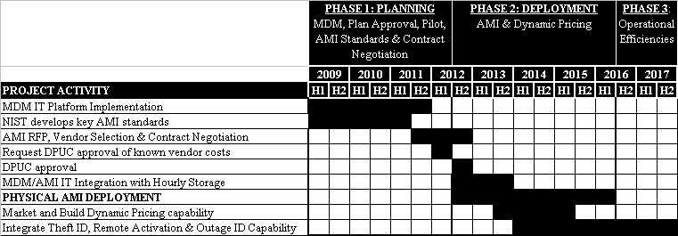

In 2009, the Company began developing a platform to enable AMI with the MDM project. Key AMI cyber-security and interoperability standards are being developed in parallel, and are estimated to be near complete by mid-2011. Depending on AMI standards progress, the Company will move forward in 2011 with a formal Request for Proposal for an AMI technology selection. Negotiated costs will be submitted in a proposed cost recovery plan to the Department by July 31, 2012. Assuming approval Q3 2012 by the DPUC, the Company will begin deploying AMI by December 31, 2012 with a four-year AMI implementation. During the physical AMI deployment, the Company will build the IT capabilities required to provide dynamic pricing and on-bill hourly energy usage analytics. Dynamic pricing will be available to all customers by 2016. Remaining IT capabilities to deliver outage detection, theft detection, and remote service activation operational efficiencies will be developed through 2017.

CONCLUSION
Based on the Company’s assessment in the base case, the Company finds that a full AMI deployment with dynamic pricing will be cost effective. An AMI and dynamic pricing deployment should begin in Q4 2012, once key AMI standards are near completion and the MDM platform is implemented. The Company proposes to submit a cost recovery filing for negotiated AMI vendor costs once the technology is selected and costs are known, by July 31, 2012.

AMI and dynamic pricing deployment costs are relatively known, however, the benefits are dependent on external factors that are highly variable. Most significant of those external factors is that customers must have a long-term response to dynamic pricing and energy conservation in order to make AMI cost effective.

The potential for customer behavior to change significantly, for better or for worse, over the twenty-year life of the meter have been captured and shared in the cost benefit analysis as the best, worst and base case scenarios.

NEXT STEPS
The Company requests conditional approval of the Plan to begin an AMI deployment by December 31, 2012. This approval would be subject to their review and approval of cost recovery via the proposed July 31, 2012 subsequent Company filing.

The Company anticipates incurring incremental expense as it plans for the AMI and Dynamic Pricing deployment and proposes continued recovery for incremental costs incurred through Federally Mandated Congestion Charges (“FMCCs”), and proposes applying the existing unused portion of the Plan-it Wise Pilot budget (approximately $1 million) towards this purpose. Costs may include additional pilots.

Prior to commencing full deployment, the Company proposes submitting the following filings to the Department:
- On or before October 31, 2011 - Informational update on key AMI standards, AMI technology, AMI deployments and Smart Controlling Technologies in the industry.
- On or before July 31, 2012 - Request for Department approval of AMI & dynamic pricing cost recovery based on AMI vendor responses to the Company’s RFP.

This includes the AMI meter, plus the supporting AMI communications network, divided by the number of meters.
This price is approximately 30% higher on average than the prices forecast in the 2010 Integrated Resource Plan (“IRP”)
As forecast in the Synapse Energy Economics, Inc., “Avoided Energy Supply Costs in New England” 2009 Report.
Dynamic pricing enrollment levels achieved in the 2009 Pilot.
As projected in the 2010 Integrated Resource Plan (“IRP”).
The peak load reduction impact forecasted for a typical summer was higher than the Plan-it Wise Pilot results. See Appendix C - Plan-it Wise Pilot Demographic Analysis Results for typical summer analysis.
Costs to pay for the rebate are included in the calculation of the $153 NPV value.
Thirty seven percent of CL&P customers have CAC.
In CL&P’s DPUC filing dated March 30, 2007, CL&P estimated the equivalent AMI costs were approximately $264 million.
OPower, an energy efficiency software company, has the largest experience with approximately one million U.S. customers contracted. On average, by these customers experience a 2.0 percent reduction in consumption when compared to a statistically-similar control group, with reductions in consumption ranging between 1.5% and 4.5%. These results have been independently verified by industry experts and world-renowned behavioral economists.
Estimated Value of Service Reliability for Electric Utility Customers in the United States - Ernest Orlando Lawrence Berkeley National Laboratory - June 2009.

